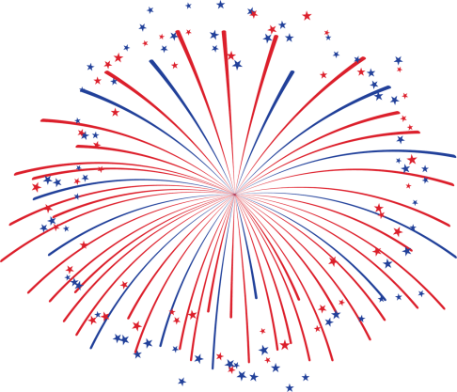
Purchase a Firework
Name: _______________________________________________
Address: __________________________________________________________
City: ________________ State: CA Zip Code: ________ Phone #: (_____) _____________
1- Firework Shell = $5 x’s ___________ total $___________
2- Firework Shells = $9 x’s ___________ total $___________
4- Firework Shells = $18 x’s ___________ total $___________
10- Firework Shells = $48 x’s ___________ total $___________
15- Firework Shells = $73 x’s ___________ total $___________
25- Firework Shells = $123 x’s ___________ total $___________
50- Firework Shells = $248 x’s ___________ total $___________
100- Firework Shells & Dedication = $498 x’s _____ total $___________
Grand total $ _________
Thank you for supporting our show,
Ojai Independence Day Committee
Ojai Independence Day Committee * P.O. Box 1176 * Ojai, Ca * 93023

Only available with the purchase of 100 Fireworks.
In Memory of we dedicate these to:_______________________________________________

